Week #8

Create a class FRUIT which has data members color, taste and price. Also create a method display() which will print values of FRUIT object. Create three objects of FRUIT class and call their display() methods.
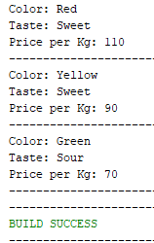
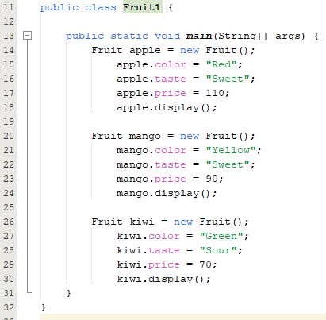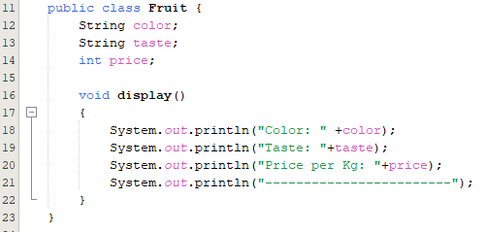

Create a class FRUIT which has data members color, taste and price. It has a method setDetails() which will set the values of color, taste and price. Also create a method display() which will print values of FRUIT object.
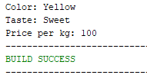
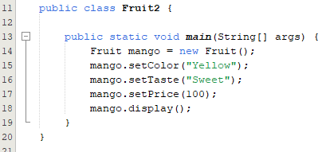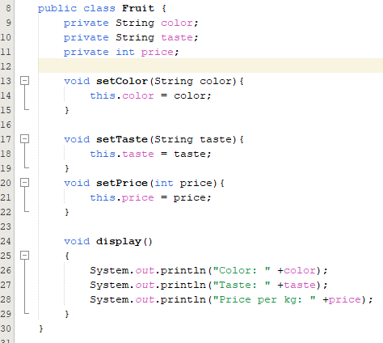

In previous question, set the values of using color, taste and price using Constructor.
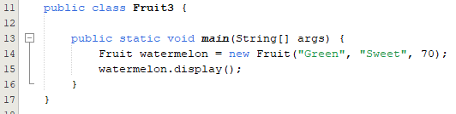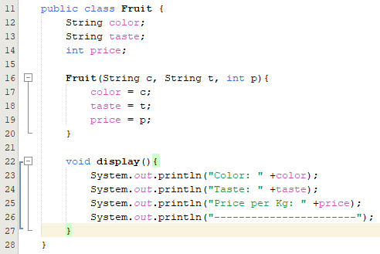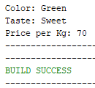

Add one-argument constructor and two-argument constructor in addition to default constructor in FRUIT class.
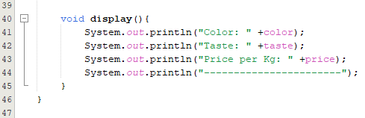
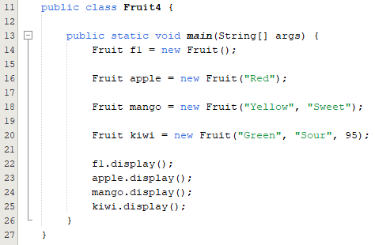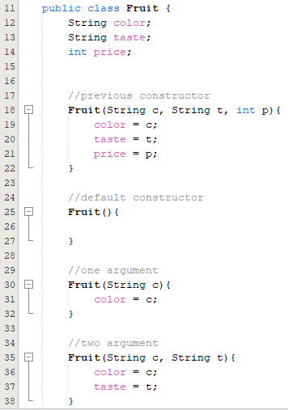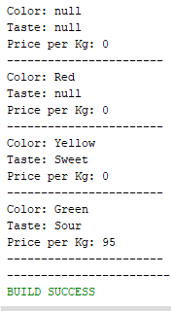

Create a class CAR with the following details:
Data members: model, color, price.
Member methods: setDetails(), getDetails(), display()
More details in the question.

